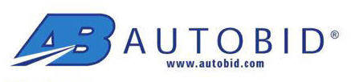 |  |  | Heavy Equipment Total Loss |  |  |  | Phone 800-875-2217 Fax 913-825-4801
 |  |  |  |  |  |  | Date Requested:
Autobid Request No | Company Name |  |  |  | Adjuster Name |  | Adjuster Phone No |  | Loss Date
Claim No | File # |  |  |  | Insured Name |  | Insured Phone No |  | Loss Type
Market Area (City/Zip) |  |  |  |  | Claimant Name |  | Claimant Phone No
Adjuster eMail address |  |  |  |  | Appraiser Name | Appraiser eMail Address |  |  | Appraiser Phone No
VIN |  | Year |  | Make |  | Model
Style |  | Engine |  | Transmission |  | Mileage
Interior Condition |  | Above Average Average Below Average |  |  |  | Prior Damage |  | $
Exterior Condition |  | Above Average Average Below Average |  |  |  | Remarks on Condition
Tires Condition |  | Above Average Average Below Average
Equipment
 | Enclosed ROPS |  |  |  |  | Others
 | Open ROPS
 | Air Conditioning
Comments/detail of aftermarket items

